RESUME

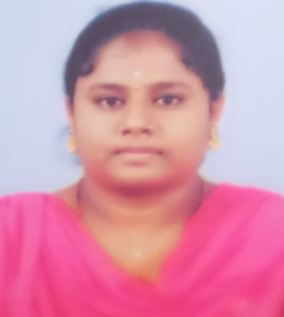

MYTHILY L

1/79, Vinayagar Kovil West Street,  
Kunnathur, Coimbatore – 641107.

C:\Users\Admin- 1\Desktop\2055904.png Phone: +91 9597849228

C:\Users\Admin- 1\Desktop\pngtree-email-icon-png-image_1757854.jpg Email id: [mythilymythily@gmail.com](mailto:mythilymythily@gmail.com)

CAREER OBJECTIVE

Seeking a position to utilize my skills in operations in an organization and would like to learn continuously, with great involvement and hard work and to be a dynamic professional willing to take challenging assignment.

EDUCATION QUALIFICATION

| DEGREE | INSTITUTE | BOARD/  UNIVERSITY | PERCENTAGE OF MARKS | YEAR OF PASSING |
| --- | --- | --- | --- | --- |
| BSC CS | PPG College Of Arts & Science  Coimbatore | Bharathiyar  University | 83.11% | Pursuing |
| HSC | KG Girls Higher Secondary School  Annur | State Board | 83% | 2021 |
| SSLC | KG Girls Higher Secondary School  Peelamedu | State Board | 77.2% | 2019 |

SKILLS

* Programmer
* MS Word and Excel
* Time Management Skills

AREA OF INTEREST

* PYTHON
* HTML
* C++
* Java

HOBBIES

* Cooking
* Throwball

STRENGTH

* Positive Attitude
* Solving Problems
* Team Management

ACHIEVEMENTS

* Learnathon by ICT Academy Completed 10+ Online Course
* Secured in certificated codeathon competition
* NCC Volunteer
* Secured certificated in hackathon conducted by PPG College of Arts and Science

PERSONAL PROFILE

Father’s Name : V.Leelakrishnan

Date of Birth : 22/06/2004

Nationality : Indian

Gender : Female

Marital Status : Unmarried

Language Known : English, Tamil

DECLARATION

I hereby declare that the particulars furnished above are true and correct to the best of my knowledge and belief.

Place: Coimbatore Signature

Date: